Test

Function: Admin change the business time
Input: a time
Expected output: time should be presented for customer to choose
Test result:
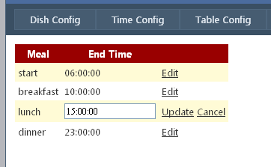

Function: Admin add the information of a table
Input: a table information
Expected output: table information be updated, is presented in customer profile
Test result:
New table information added successfully, in customer profile: this table is now available

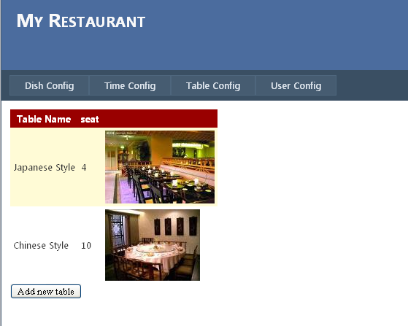

Function: Admin edit the information of a user
Input: information of an user， mail = Nancy@mail.com
Expected output: table information is updated in database
Test result: Record is updated

Function: Admin assign a new manager of the restaurant
Input: information of the new manager
Expected output: manager record is inserted into database, and be updated in view
Test result
The new manager item I presented in records
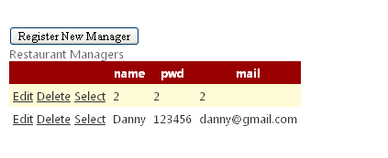

Function: Customer login
Case 1
Input: name=Nancy, password=123456
Expected output: login succeed
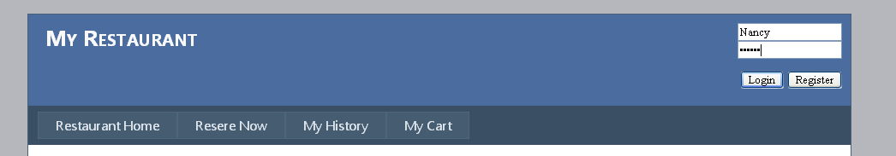

Login successfully

Case2
Input name=Nancy, password=1234
Expected output: login fails
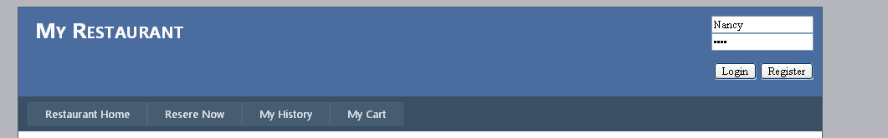

Function: customer reserve a meal in restaurant
Case 1:
Input time=2011-04-21 7:00 table number=1
Output:
all tables should available,
Time available in dropdownlist should be in the collection {7:00, 8:00, 9:00,10:00}
this reservation should be inserted into database

Case 2
Input time=2011-04-21 9:00 table number=2
Output: table ‘1’ should be excluded from the available table
In the same duration with another reservation, the table Japanese Style is not available now yet.
Test Result: success

Function: add dishes to shopping cart
Input: click the button to add to shopping cart
Output: success information
Dish should be added to shopping cart and will be presented when customer check his shopping cart
Test Result: success
Shopping cart information:
Two items have been added successfully

Function: recommended hot tags and dishes
Input: none
Expected Ouput: hot tags list order by popularity
Hot dish list order by popularity
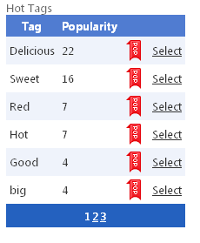
Hot dishsh
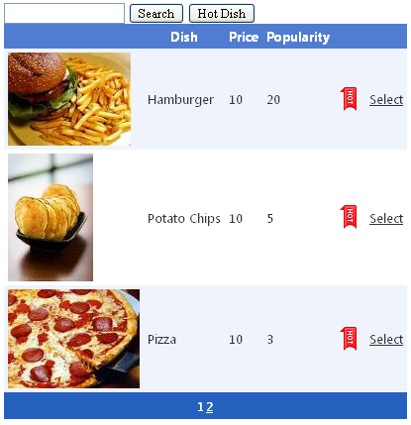

Function: search Dish
Input: search keyword
Output: dishes whose name or description contains the keyword
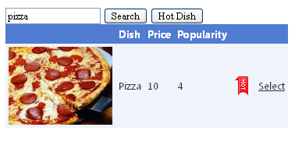
Function Show the state of all tables
Input: current time = 16:05
Reservation 1 arrive time = 16:00, table name=1
Reservation 2 arrive time = 17:00, table name= 2
Expected output: table #1state = TIMEOUT
table #2 state = RESERVED
Other table state = AVAILABLE

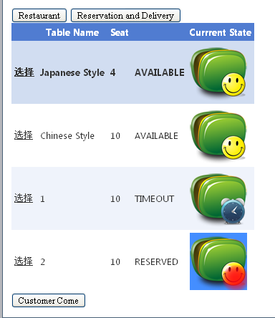

Function: Manager finishsthe meal in a table
Input: select table Japanese Style, click the button Finish
Expected Output: redirect to the page of the bill generated in this table and the table state turn to AVAILABLE
Test result: success

Function: Cancel the timeout reservation
Input: select a timeout reservation, click the button Cancel
Output: the reservation delete from the TIMEOUT list
Test Result: reservation is successfully deleted

Function: Auto check the RESERVED and TIMOUT reservation
Auto check the TIMEOUT and UNDELIVED delivery
Input: current time = 17:15
Reservation case 1: customer name = nancy5, arrive time = 16:00
Reservation case 2: customer name = nancy6, arrive time = 17:00
Delivery case 1: customer name = nancy8, delive time = 17:10
Delivery case 2: customer name = nancy9, delive time = 17:30
Output: All the reservation and delivery matching the condition
